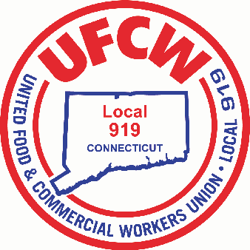

MARK A. ESPINOSA
President

Stop & Shop Employees,
Members of Local 919 UFCW,

We are pleased to announce that your new 4-Year Successor Work Contract was UNANIMOUSLY ratified by those members in attendance at this mornings scheduled meeting. Ratification Bonuses should be paid out by March 14th and raises are effective 3/1/26! We will be passing out the Memorandum of Agreement in the coming week. We thank you for your trust and faith during these negotiations. Do not hesitate to contact the Union Office and speak with your Business Agent with any questions you may have.

U N I T E D F O O D A N D C O M M E R C I A L W O R K E R S U N I O N

L O C A L 9 1 9

U.F.C.W.
6 Hyde Road • Farmington, Connecticut 06032-2802 • Tel. 860-677-9333 Outside Local Dialing Area 1-800-842-2215
www.ufcw919.org
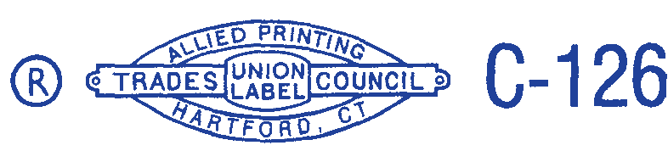

JASON DOKLA
Secretary-Treasurer

