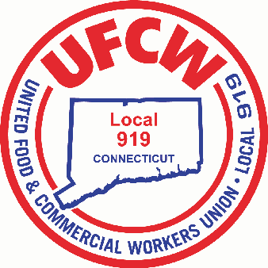

MARK A. ESPINOSA
President

TENTATIVE AGREEMENT REACHED
Your bargaining team is pleased to announce that we have reached a tentative four-year agreement, concluding the most recent round of contract negotiations.
In addition to annual wage increases, this proposed agreement preserves the strength and stability of our health insurance and pension benefits, maintaining the high standards that our membership has worked hard to achieve. Throughout negotiations, your bargaining team remained focused on securing an agreement that reflects the priorities expressed by members and protects the long-term economic security of working families.
Your strength and unity at every stage of negotiations made this outcome possible.
As previously announced, the Agreement will be presented to the membership for a ratification vote. The vote will take place on Sunday, February 15:

Ratification Meeting & Vote
Location: Doubletree by Hilton Hotel
42 Century Drive, Bristol, CT 06010
Time: 9 A.M.

All members are encouraged to attend, review the full details of the agreement, ask any questions they may have, and exercise their right to vote.

We look forward to seeing you at the meeting!

In Solidarity,
Your Stop & Shop Bargaining Committee

U N I T E D F O O D A N D C O M M E R C I A L W O R K E R S U N I O N

L O C A L 9 1 9

U.F.C.W.
6 Hyde Road • Farmington, Connecticut 06032-2802 • Tel. 860-677-9333 Outside Local Dialing Area 1-800-842-2215
www.ufcw919.org
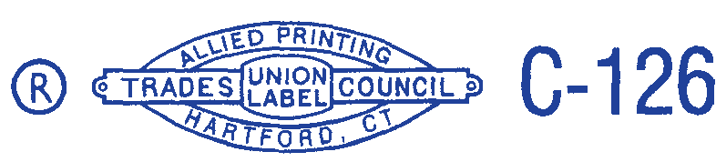

JASON DOKLA
Secretary-Treasurer

