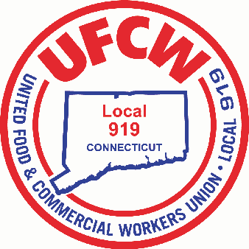

MARK A. ESPINOSA
President

Dear Members,

On January 7th and 8th, your bargaining team, made up of union leadership and your fellow Stop & Shop members at UFCW Locals 328, 371, 919, 1445, and 1459, returned to the table for the second unity bargaining session for your 2026 Stop & Shop contract.

This session built on earlier meetings and included continued discussion around wages, benefits, and working conditions that directly affect members and their families.

We came prepared to engage in good-faith discussions focused on ensuring the long-term stability and affordability of members’ healthcare. A significant portion of the conversation centered on how the Health and Welfare Fund is funded and maintained. While the Company continued to hold firm on its position, your bargaining team emphasized the importance of responsibly funding the plan to ensure benefits remain strong, affordable, and sustainable for members and their families over time.

In addition, discussions took place around workplace issues such as expanding eligibility for weekend overtime pay, the addition of holidays, and appropriate staffing levels. These topics speak directly to the fairness, work-life balance, and safe, sustainable working conditions that members deserve and your bargaining team made it clear that these are important.

Negotiations will continue next week on January 13th. In the meantime, we remain united, focused, and committed to securing a fair and responsible agreement that reflects the priorities you have shared and protects the wages, benefits, and working conditions you have earned.

In Solidarity,

Mark A. Espinosa
President

U N I T E D F O O D A N D C O M M E R C I A L W O R K E R S U N I O N

L O C A L 9 1 9

U.F.C.W.
6 Hyde Road • Farmington, Connecticut 06032-2802 • Tel. 860-677-9333 Outside Local Dialing Area 1-800-842-2215
www.ufcw919.org
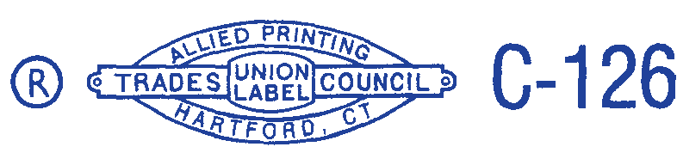

JASON DOKLA
Secretary-Treasurer

