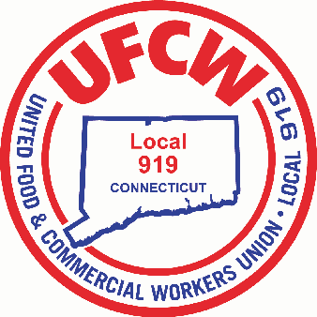

MARK A. ESPINOSA
President

December 11, 2025

Dear Local 919 Membership,

We are excited to report to you that contract negotiations with your Employer are officially underway. We met with Stop & Shop leadership for opening remarks by both your Employer and all 5 Union Presidents. In addition, all 5 Local Unions (Local 919, Local 371, Local 1459, Local 328 and Local 1445) gave Stop & Shop initial contract proposals representing many of the suggestions received by the membership through the survey questionnaires. We look forward to working through the many challenges such as maintaining your affordable healthcare, wages and protecting your pension. We are encouraged by Stop & Shop’s willingness to begin early as well as their stated desire to negotiate a fair and equitable successor contract that values you and the work that you do every day. We will keep you updated as we progress. We ask for your patience and trust during these negotiations.

In Solidarity,

Your UFCW Local 919 Leadership Team

U N I T E D F O O D A N D C O M M E R C I A L W O R K E R S U N I O N

L O C A L 9 1 9

U.F.C.W.
6 Hyde Road • Farmington, Connecticut 06032-2802 • Tel. 860-677-9333 Outside Local Dialing Area 1-800-842-2215
www.ufcw919.org
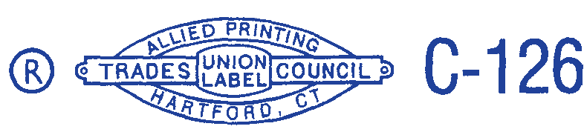

JASON DOKLA
Secretary-Treasurer

