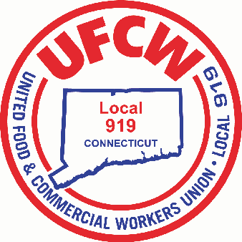

MARK A. ESPINOSA
President
December 17, 2025

Dear Membership,

Today, your bargaining team — made up of union leadership and your fellow Stop & Shop members at UFCW Locals 328,371,919,1445, and 1459 — wrapped up the second unity bargaining session for your 2026 Stop & Shop contract.
Over the past two days, we continued to exchange proposals and have dialogue with the company, while stressing to them the issues that matter most to you and your coworkers:

- Meaningful wage increases that keep up with the rising cost of living.
- Securing the employer contributions necessary to maintain our Health and Welfare Fund and protecting the high quality and affordable benefits that our members and their families rely on.
- Addressing staffing levels to ensure safe and sustainable working conditions.

Overall, these meetings were a productive exchange of ideas that we can build upon in upcoming sessions. As negotiations move forward, we look forward to getting into our core economic proposals — specifically those concerning wages and health & welfare. We have secured additional bargaining dates throughout January and, as always, will provide updates after.

As we approach the holidays, we want to thank each and every one of you. You are the reason the holidays happen for so many customers and their families, and your hard work does not go unnoticed. We remain as committed and unified as ever in fighting for the wages, benefits, staffing, and respect you deserve.

As always, we remain, your bargaining team,

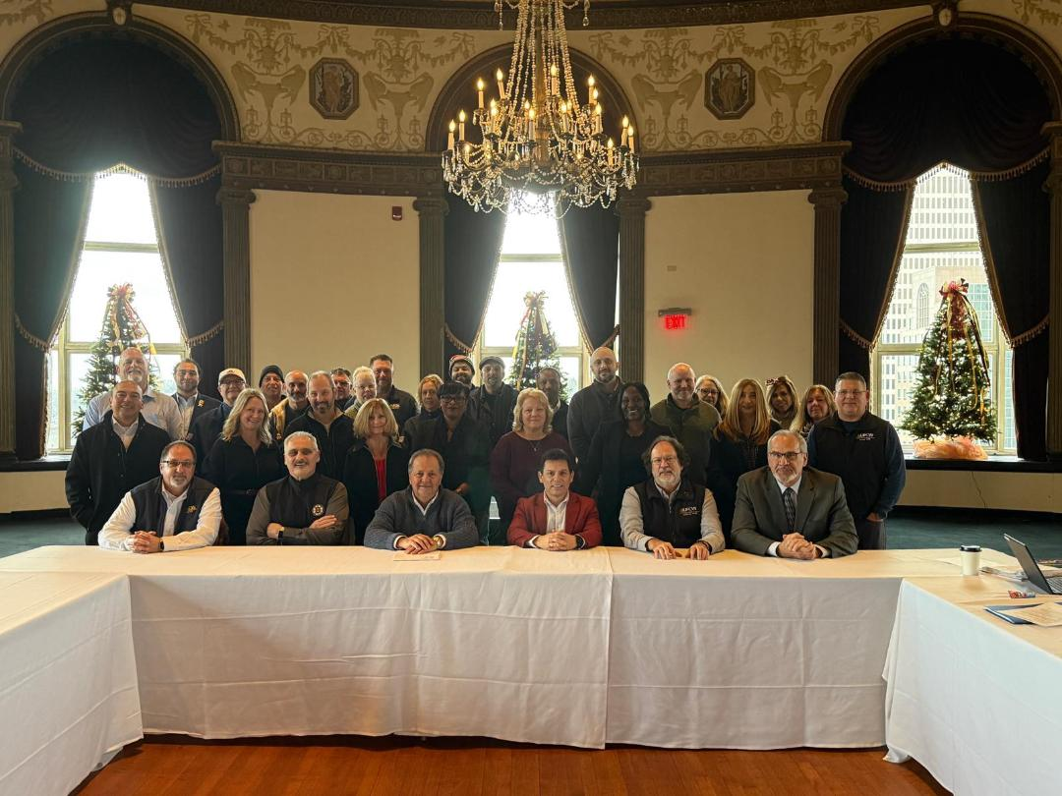
U N I T E D F O O D A N D C O M M E R C I A L W O R K E R S U N I O N

L O C A L 9 1 9

U.F.C.W.
6 Hyde Road • Farmington, Connecticut 06032-2802 • Tel. 860-677-9333 Outside Local Dialing Area 1-800-842-2215
www.ufcw919.org
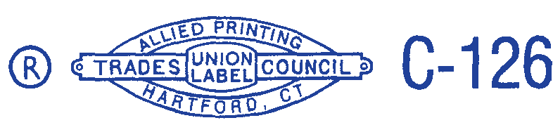

JASON DOKLA
Secretary-Treasurer

