**Celebrate Labor Day With Union-Made Products**

This Labor Day, choose union-made goods and enjoy delicious, high-quality products prepared by UFCW members. From union-made hot dogs and burgers to all the best fixings, we’ve got your table covered!

[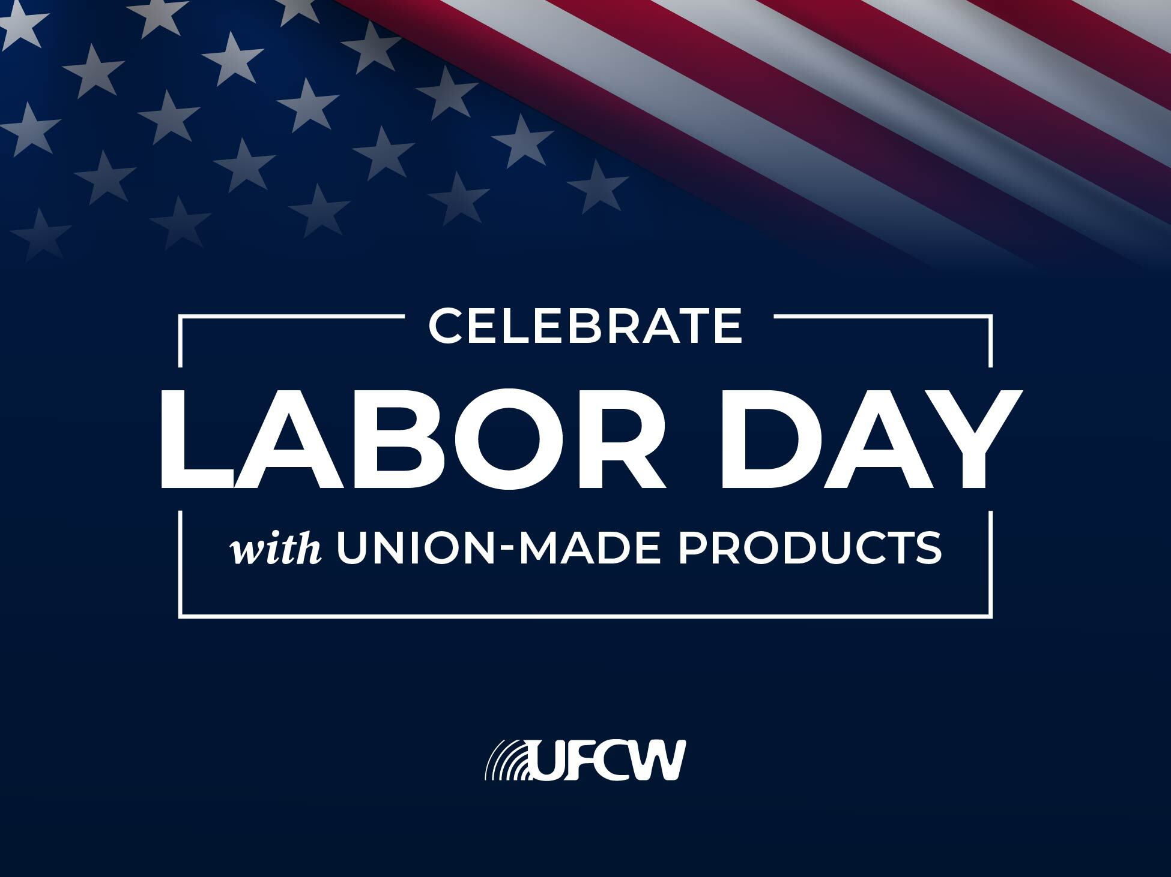](http://forlocals.ufcw.org/files/2025/08/Labor-Day-2025-Image.jpg)

**Buns**

Bunny bread

151 Foods under Amoroso brand

**Beef**

Holten Meat

Cargill and National Beef

National Beef

JBS Ground Beef

Strauss Veal

Fair Oaks Farms

Schweid & Sons

AVA

Plymouth Beef

Garden Manor

Schuster Meat

King Solomon

Meat innovations

**Burgers & Dogs**

Koegel Meats

Berks

Aguer Dale

Oscar Mayer

Hofmann’s

Honest John

Sahlen Packing

Frank Wardynski & Sons

Empire Kosher

Ball Park

Boars Head hot dogs

Butterball

Foster Farms fresh chicken

Smithfield Sausage

Nathan’s Ball Park hot dogs

Wenzel’s sausage

**Ketchup**

Heinz

**Mustard**

Huffman’s Mustard

French’s/McCormick

Dearborn Mustard

Heinz

**Pickles**

Van Holten’s

Bay Valley Foods

United Pickle

Ba Tampte

L&S Packing

Vlasic

Dietz & Watson

**Onions**

Boar’s Head

L&S Packing

**Mayonnaise**

Hellmann’s