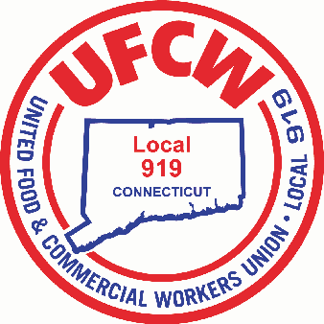

MARK A. ESPINOSA

President

July 9, 2025

**To All Members of UFCW Union Local 919:**

Please be advised that nominations for officers of Local 919 were conducted on July 7, 2025.

All officers of the Executive Board were unopposed candidates and therefore elected by acclamation for the new three-year term commencing January 1, 2026. They are as follows:

Mark A. Espinosa, President Jason Dokla, Secretary-Treasurer

Jason K. Frechette, Vice President Joanna Santana, Recorder

Robert Giglietti, Vice President Julliette Sabo, Vice President

(Stop & Shop #606) (Stop & Shop #673)

Gary Sanderson, Vice President Sherri Tollefson, Vice President

(Stop & Shop #689) (Stop & Shop #614)

Chris Mauro, Vice President

(Stop & Shop #696)

For the opportunity of continued service to you, the Executive Board thanks you.

Sincerely and Fraternally,

Emily Sabo

Election Chairperson

U N I T E D F O O D A N D C O M M E R C I A L W O R K E R S U N I O N

**L O C A L 9 1 9**

U.F.C.W.

6 Hyde Road • Farmington, Connecticut 06032-2802 • Tel. 860-677-9333 Outside Local Dialing Area 1-800-842-2215

[www.ufcw919.org](http://www.ufcw919.org/)

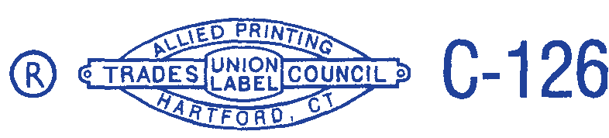



JASON DOKLA

Secretary-Treasurer