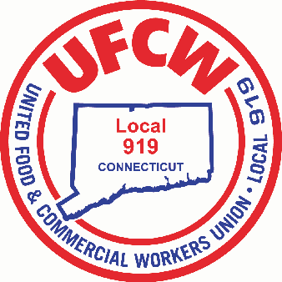

MARK A. ESPINOSA

President

Congratulations to the recipients of the

UFCW Local 919 2025-2026 Scholarship Winners!

Helen Baxter- Parent is Russell Baxter at Store #695

Brady Awua-Peasah- Member at Store #674

Dillon Bargagna- Member at Store #636

Thomas Costa- Member at Store #632

Ethyn Iasparra- Parent is Nicole Guida Store #687

Mia Voiland- Parents are James Voiland Store #689 Kathleen Collins-Voiland Store #2611

Jaylon Raphael- Parent is Jean Max Raphael Store #667

Muriel Stankeviciute- Parent is Daiva Stankeviciute at Store #630

Sarah Svitlik- Parent is Yvonne Svitlik at Store #657

Kaitlyn Swindon- Parent is Jonathan Swindon at Store # 656

U N I T E D F O O D A N D C O M M E R C I A L W O R K E R S U N I O N

**L O C A L 9 1 9**

U.F.C.W.

6 Hyde Road • Farmington, Connecticut 06032-2802 • Tel. 860-677-9333 Outside Local Dialing Area 1-800-842-2215

[www.ufcw919.org](http://www.ufcw919.org/)

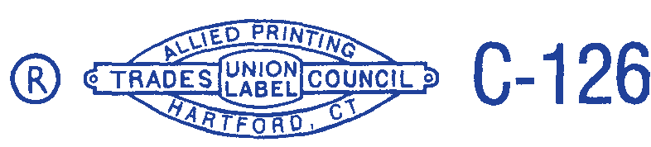



JASON DOKLA

Secretary-Treasurer