**UFCW Calls for Equality and Unity on MLK Day**

On Jan. 20—Martin Luther King Jr. Day—the UFCW honored Dr. King’s legacy and reaffirmed our union’s commitment to building a better future for all Americans.

[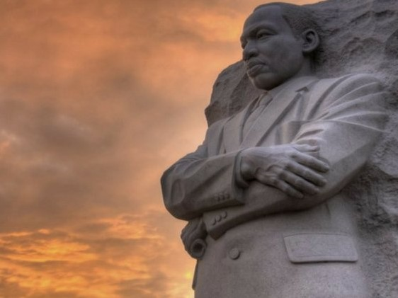](http://forlocals.ufcw.org/files/2025/01/MLK-Image-002.jpg)

“Today, the UFCW honors the legacy of Dr. Martin Luther King Jr. and his dedication to fighting not only for equality, but dignity, for every person in this country,” said UFCW International President Marc Perrone in a [statement](https://www.ufcw.org/press-releases/ufcw-statement-on-martin-luther-king-jr-day-2/). “Dr. King envisioned a better future for everyone, not just a select few, and that vision is one that we are still working to achieve every day.”

“As we look towards the future, we must remember Dr. King’s legacy and carry with us the will to stand together, show solidarity, and fight for a nation that uplifts everyone.”