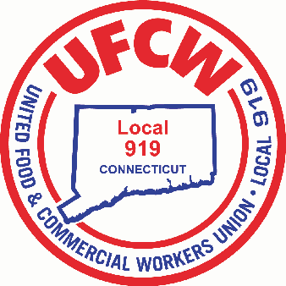

MARK A. ESPINOSA

President

**Statement regarding Stop & Shop’s Announcement on May 23, 2024**

May 24,2024

Dear Local 919 Membership of Stop & Shop,

As many of you may have already heard yesterday, Stop & Shop announced during their investors call, they plan to “optimize their store portfolio,” more specifically, they plan to close some of their underperforming stores to restore health and maximize profitability to the Company. It is most important to note, that the Company has NOT disclosed when they plan to close any stores, which stores they plan to close or how many stores they plan to close within the multiple states that they operate. What we can tell you is that labor relations between Local 919 and your Employer will continue to provide productive communication as this process unfolds, and the same is true for each of the Local Unions that have a bargaining relationship with Stop & Shop.

Your Union Leadership takes the responsibility of being your voice, your representatives very seriously and we will approach this latest news from your employer with your best interest as top priority. In the meantime, it is ever more important to work hard for your employer and your customers who shop your stores every day. Your customers come back because of you, they come back because they trust you and the service and products that you provide for them and their families. Your customers need you as much as we need them. Please do not hesitate to call your Union Office should you have questions and/or concerns. We will communicate with you any information as it becomes available. We wish you a Safe and Happy Memorial Day holiday, as we honor America’s Military who lost their lives in service to our country.

Sincerely and fraternally,

Mark A. Espinosa Jason Dokla

President Secretary-Treasurer

U N I T E D F O O D A N D C O M M E R C I A L W O R K E R S U N I O N

**L O C A L 9 1 9**

U.F.C.W.

6 Hyde Road • Farmington, Connecticut 06032-2802 • Tel. 860-677-9333 Outside Local Dialing Area 1-800-842-2215

[www.ufcw919.org](http://www.ufcw919.org/)

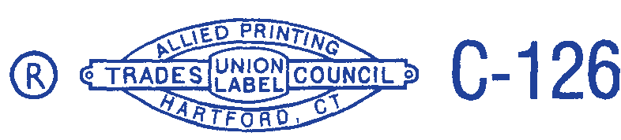



JASON DOKLA

Secretary-Treasurer