Cannabis Workers in Connecticut Continue to Join Local 919
Over 70 workers at CTPharma, a medical and adult use cannabis producer in Rocky Hill, Conn., joined UFCW Local 919 on June 13. This facility is owned and operated by Verano.
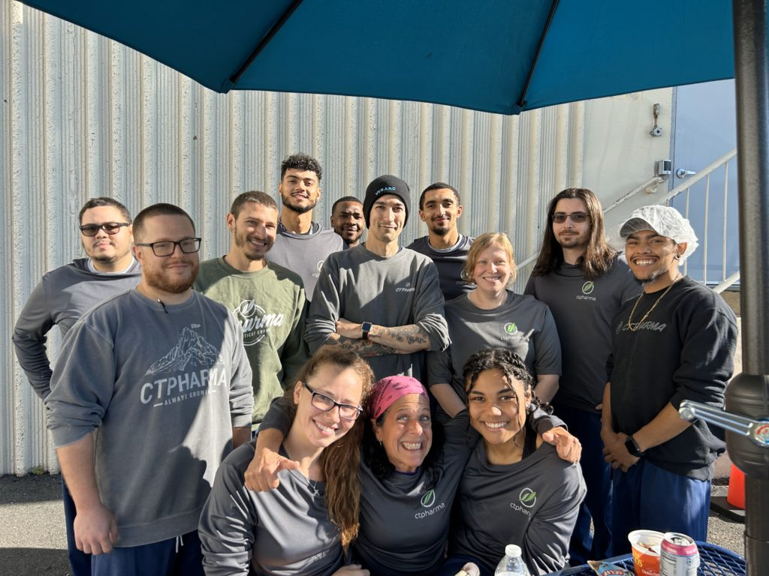
These workers joined our union family to be a part of making the Connecticut cannabis industry stronger. They formed their union through the Labor Peace Agreement process.
This organizing victory marks the third cannabis win for UFCW Local 919 in Connecticut this year. Workers at Advanced Grow Labs in West Haven made history by becoming the first cannabis unit in the state to unionize by joining UFCW Local 919 earlier this year, and workers at the Caring Nature Dispensary in Waterbury unionized in June.
“We look forward to working with the bargaining committee at CTPharma to secure a great first- time contract that will give these workers the respect and job protections they deserve,” said UFCW Local 919 President Mark A. Espinosa.

