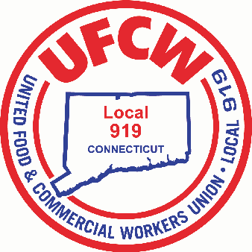

MARK A. ESPINOSA

President

**LOCAL UNION OFFICERS**

**ELECTED BY ACCLAMATION**

On July 5, 2022, Local Union Officers were nominated by Petition, unopposed, and elected by acclamation to a three-year term.

**-President-**

Mark A. Espinosa

**-Secretary-Treasurer- -Recorder-**

Jason Dokla Edward Pryjmaczuk

**-6 Vice Presidents-**

Jason K. Frechette (Executive Vice President)

Juliette Sabo

Robert Giglietti

John W. Casey, III

Wanda Jablonecki

Gary Sanderson

U N I T E D F O O D A N D C O M M E R C I A L W O R K E R S U N I O N

**L O C A L 9 1 9**

U.F.C.W.

6 Hyde Road • Farmington, Connecticut 06032-2802 • Tel. 860-677-9333 Outside Local Dialing Area 1-800-842-2215

[www.ufcw919.org](http://www.ufcw919.org/)

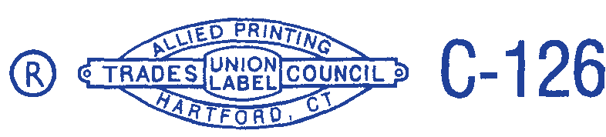



JASON DOKLA

Secretary-Treasurer