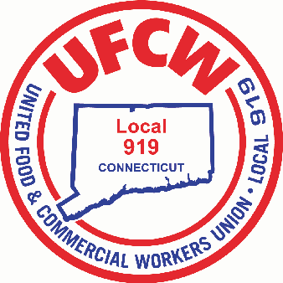

MARK A. ESPINOSA

President

Congratulations to the

Recipients of the UFCW Local 919 2022-2023 Scholarship Awards:

Nicholas Braychak- Father is Keith Braychak Store #603

Janesa Castro- Member at Store #674

Katelyn Robbins- Father is Jeff Robins Store #624

Avery Kruczek- Member at Store #638

Emily Libowitz- Mother is Toni Ann Libowitz #639

Samantha Morgan- Mother is Deborah Morgan Store #644

Lucas Regalado- Father is Paulo Regalado Store #2633

Patrick Spychalla- Member at Store #620

Muriel Stankeviciute- Mother is Daiva Stankeviciute Store #651

Kristie Zator- Member at Store #674

U N I T E D F O O D A N D C O M M E R C I A L W O R K E R S U N I O N

**L O C A L 9 1 9**

U.F.C.W.

6 Hyde Road • Farmington, Connecticut 06032-2802 • Tel. 860-677-9333 Outside Local Dialing Area 1-800-842-2215

[www.ufcw919.org](http://www.ufcw919.org/)

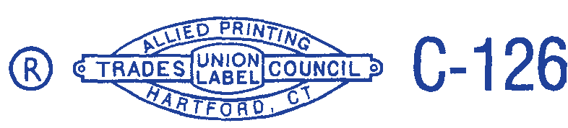



JASON DOKLA

Secretary-Treasurer