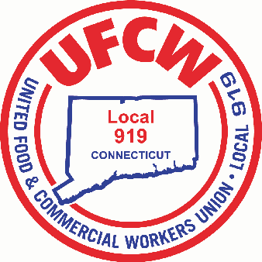

MARK A. ESPINOSA

President

June 1, 2022

Dear Member,

We hope this letter finds you and your family well. Among the other benefits of union membership, we would like to extend the following new consulting services to members as follows:

* Credit Card Debt Advice
* Personal and Business Insurance Advice
* Bitcoin
* Home Purchase Advice
* Auto Purchase Advice
* Divorce Advise
* College Saving Ideas
* Social Security Advice (8% Rule?)
* Long-Term Care Insurance Advice
* Health Savings Account (HSA) Ideas
* Buying or Selling a home or Rental Property
* Medicare and Medicaid

Our new service includes a free one-hour consultation either in person or over the phone. If you have any questions regarding the aforementioned list, or if these services can be of use to you, please contact the Union’s Accountant, Legowski & Company, at 860-676-1040 or your Business Agent at 860-677-9333.

In Solidarity,

Mark A. Espinosa

President

UFCW Local 919

U N I T E D F O O D A N D C O M M E R C I A L W O R K E R S U N I O N

**L O C A L 9 1 9**

U.F.C.W.

6 Hyde Road • Farmington, Connecticut 06032-2802 • Tel. 860-677-9333 Outside Local Dialing Area 1-800-842-2215

[www.ufcw919.org](http://www.ufcw919.org/)





JASON DOKLA

Secretary-Treasurer