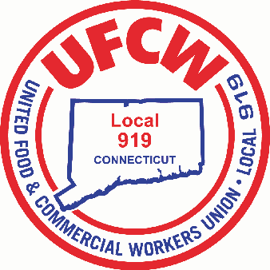

MARK A. ESPINOSA

President

May 3, 2021

Office of Governor Lamont

State Capitol

210 Capitol Avenue

Hartford, CT 06106

Governor Lamont:

I am the President of the United Food and Commercial Workers Union, Local 919. We represent over 7,000 grocery and retail workers here in Connecticut. I am writing to you regarding your proposal of “combat pay bonuses for front-line workers.” It is our hope that my members employed at Stop & Shop will be included in your proposal for combat pay bonuses for front-line workers to acknowledge their hard work and sacrifice. Since March of 2020, these grocery workers have worked tirelessly on the front lines to put food on the table for Connecticut families. Throughout the pandemic grocery workers have selflessly put their lives on the line—in the same way health care and other essential workers have. They certainly did not have the luxury of working from home. We have experienced devastating loss and illness, with these workers paying the ultimate price to continue to serve their community.

During the first few weeks of this pandemic, our union worked to convince Stop & Shop directly to take the proper safety measures that are common today, but were not back then. If you recall, initial guidance meant that our workforce was not able to wear face masks nor limit the density in the stores. They did not have access to life-saving PPE including plexiglass shields, hand sanitizer etc.

Other than the physical challenges faced, our members also experienced unprecedented mental stress, exhaustion and fear. We are now dealing with the “invisible wounds” that our members carry such as anxiety, depression and PTSD, that will last long after this pandemic is over.

It is time to truly appreciate Connecticut’s grocery workers with more than verbal affirmations and words of thanks. It is paramount to recognize their sacrifices and the contributions they have made across the state to ensure that Connecticut families had access to food, water and personal care items, without which the effects of the pandemic would have been exacerbated. I trust that you too, will see their value as well as the sacrifices made during this pandemic and classify grocery workers as essential workers eligible for any and all compensation packages during the COVID-19 pandemic.

In solidarity

Mark A. Espinosa

President

U N I T E D F O O D A N D C O M M E R C I A L W O R K E R S U N I O N

**L O C A L 9 1 9**

U.F.C.W.

6 Hyde Road • Farmington, Connecticut 06032-2802 • Tel. 860-677-9333 Outside Local Dialing Area 1-800-842-2215

[www.ufcw919.org](http://www.ufcw919.org/)





JASON DOKLA

Secretary-Treasurer