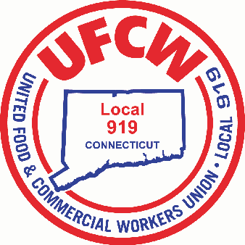

MARK A. ESPINOSA
President
August 24, 2020

Dear UFCW Local 919 Member:
As we enter into the sixth month of this global pandemic, your International and Local union remain determined to keep our members working on the frontlines safe and to ensure that your incredible hard work and sacrifices are recognized by our employers.
Unfortunately, many top companies – across food retail, meatpacking, food processing, pharmacy, healthcare, and nursing homes – have taken away hazard pay for workers even as COVID-19 cases continue to spike across the country. Even worse, some of these companies never even gave hazard pay to begin with.
This is unacceptable, and we want you to know that we are fighting for the hazard pay you have earned and deserve.
Over the past eight weeks, your union has taken a number of actions to call for the reinstatement of hazard pay for all frontline essential workers. Among these actions include a national press conference, a letter to the top CEOs, mobilizing customers and the local community in support, and, most recently, launching petitions targeted at top companies and lawmakers, as well as partnering with Senator and Vice Presidential Candidate Kamala Harris on an op-ed condemning America’s largest grocery chains – including Amazon-Whole Foods and Kroger - for cutting hazard pay.
We want you to know that we are determined to make your voice heard, and we need your voice to do that.
Please take a minute to share your story about why hazard pay is important to you and your family.
By sharing your story, you are help us send a clear message to your employer and our elected leaders of the health risks and hazards you face at work, and why hazard pay is essential for all essential workers, like you.
Again, please share your story about the importance of hazard pay for essential workers.
To learn more about upcoming hazard pay actions across the country text PREPARED to 83071 to receive important updates.
As always, thank you for all that you do for your family and ours.
Sincerely and Fraternally,
Mark A. Espinosa
President

U N I T E D F O O D A N D C O M M E R C I A L W O R K E R S U N I O N

L O C A L 9 1 9

U.F.C.W.
6 Hyde Road • Farmington, Connecticut 06032-2802 • Tel. 860-677-9333 Outside Local Dialing Area 1-800-842-2215
www.ufcw919.org

JASON DOKLA
Secretary-Treasurer

