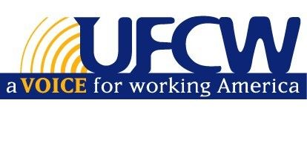
“Robert Burke Petronella Memorial Scholarship Fund”

OF THE UFCW AND PARTICIPATING EMPLOYERS NEW ENGLAND HEALTH FUND

To be eligible, a member must be in continuous good standing for at least twelve (12) months immediately
preceding June 2022. A qualified applicant is a full or part-time member, or a son, daughter or
grandchild of a member and must be graduating from high school in 2022.

I hereby apply for consideration for one of the three (3) $2,500 per school year scholarships to be awarded by the UFCW New England Health Fund Scholarship Committee.
Student's Name: _________________________________ Relationship to Member:_____________________
Address: ________________________________City:__________________________State:______Zip: ____________
Email: _________________________________________________ Phone: _________________________________
Name of Member: ____________________________________Phone:______________________________ Employer:______________________________ Employer Address: ______________________________________
I will graduate from High School on: ___________________ Name & Address of High School:___________________
______________________________________________________________________________________
I have been (or expect to be) accepted for admission to the following College, University or Trade School: List name and location of school: Type of Program: 2-year | 4-year

1. _________________________________________2._________________________________________
_________________________________________ _________________________________________
3. __________________________________________________4. __ _______________________________________________
_________________________________________ _________________________________________
STATEMENT OF INTENT & ENCLOSED INFORMATION
As required by the scholarship committee, I have enclosed:

- A clear copy of my scholastic record, with GPA and SAT scores
- A school profile of grades and class rank
- Proof of having been accepted for admission to the college or university I wish to attend
- Any activities, clubs or organizations that I participate in
- A 300 to 500-word essay on “Describe your relationship with our Union and the Labor movement; in what ways has it personally affected your life and your family’s life.”
ELECTRONIC SUBMISSION IS ACCEPTABLE - please send to contact@ufcw371.org

I further agree to use any scholarships received for college expenses during the school year.
Signature:_______________________________________________Date:_________________________

This application and all supporting material must be post-marked no later than June 1, 2022

MAIL TO: 290 POST ROAD WEST, PO BOX 470, WESTPORT, CT 06881

