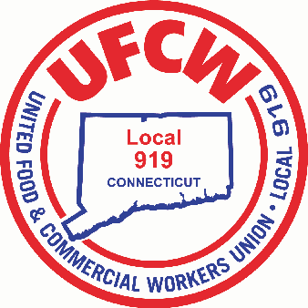

MARK A. ESPINOSA

President

To All Members of Local 919:

By now, you have heard your Company’s decision to stop the 10% Hazard Pay for all hours worked that has been in place for the last three months. Stop & Shop’s decision to stop this premium is effective July 4th. You should know that this Local Union, as well as the New York, New Jersey and New England UFCW locals have been in contact several times with you Employer to express our disagreement and outrage over their decision. We were all told as late as July 1st, that they have heard the concerns of the members voiced through their Union Representatives, but are not inclined to change their position.

Brothers and Sisters, even though “hazard pay” is not outlined in our Collective Bargaining Agreement, we will continue to advocate on your behalf. We have already begun, not only through a social media campaign, but have entered into talks with members of the CT State Legislature in order to establish a position of continuing the hazard pay legislatively. We will keep you informed as information becomes available. In the meantime, continue to wear your masks and face shields and practice safe social protocols. Thank you for all you do to serve your customers and your community during this pandemic.

Fraternally,

Mark A. Espinosa

President

U N I T E D F O O D A N D C O M M E R C I A L W O R K E R S U N I O N

**L O C A L 9 1 9**

U.F.C.W.

6 Hyde Road • Farmington, Connecticut 06032-2802 • Tel. 860-677-9333 Outside Local Dialing Area 1-800-842-2215

[www.ufcw919.org](http://www.ufcw919.org/)

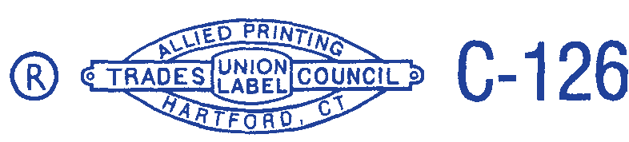



JASON DOKLA

Secretary-Treasurer