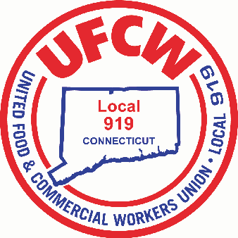

MARK A. ESPINOSA

President

**What the UFCW is doing to help workers**

From one corner of the country to the other, we are witnessing an unprecedented demand for groceries and healthcare, and it is clear that workers in those industries are facing incredibly difficult, stressful and exhausting days.

The UFCW represents not only nurses and other health care professionals who are on the front lines caring for patients, but also grocery and other food workers who are still hard at work making sure our communities have access to groceries and other essential supplies during this crisis.

The UFCW International recognizes we have to act fast to combat this threat. The actions we are taking include the following:

1. **Working with state and federal leaders** to develop immediate policies that will *protect our members’ personal and economic health*.
2. **Meeting with our largest employers** to discuss actions to *protect our members’ pay and benefits*, as well as the specific actions they are taking to *minimize our members’ exposure* to the Coronavirus.
3. **Working with our local unions** to *designate our members as “first responders”* to ensure they have immediate access to testing, and additional protections they need to be able to do their jobs.
4. Working with our local unions to **launch a series of member communications** to ensure our union is there to *answer our members’ questions and address their concerns*—whatever they may be.
5. **Coordinating with local, state, and federal authorities** about *the impact any new Coronavirus policies* could or may have on our members and employer operations.

U N I T E D F O O D A N D C O M M E R C I A L W O R K E R S U N I O N

**L O C A L 9 1 9**

U.F.C.W.

6 Hyde Road • Farmington, Connecticut 06032-2802 • Tel. 860-677-9333 Outside Local Dialing Area 1-800-842-2215

[www.ufcw919.org](http://www.ufcw919.org/)





JASON DOKLA

Secretary-Treasurer