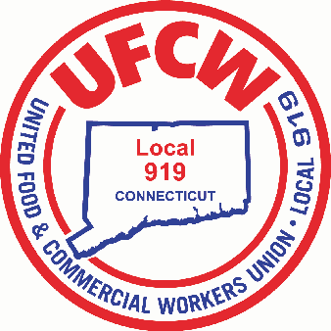

MARK A. ESPINOSA

President

David Young

International Vice President

Director, Region 1 – Northeastern

UFCW International Union

Dear Mr. Young,

As discussed, we are happy to inform you that after reviewing the current crisis that we are facing, and in light of the impact and high demand on our associates over the last few weeks, Stop & Shop has made the decision to increase our union associate’s pay by 10% until May 2nd. This is inclusive of Sunday hours and Overtime. We feel that our associates are working very hard and are proud of their commitment and loyalty to serving our customers.

Also, as discussed, we want our associates to be able to focus on their physical health and have some relief of their concerns about their financial stability. To accomplish this, Stop & Shop will temporally institute the following;

* For associates with a mandatory or precautionary order of quarantine by the state, health department, local board of health or government entity - or by mandate of the company related to a COVID-19 diagnosis - Stop & Shop will provide up to 2 weeks of paid sick leave.
* The above 2 weeks of paid sick leave is in addition to all other forms of PTO outlined in each CBA. (For Part-time associates we will use a weekly average of their past 12 weeks of hours)
* We will also work with impacted associates to make sure they understand what other additional options may be available to them through paid time off, short term disability, unemployment and other state and federal programs.
* We want to make it clear that spending time away from work because of COVID-19 will not put your job at risk
* Our lives are being disrupted in unprecedented ways, and with schools and childcare facilities closing, we are proud to be offering flexible hours that accommodate different types of schedules.
* Stop & Shop also understands that some associates may be absent due to a personal decision to self-quarantine, to care for sick family members or for other events related to COVID-19.
* Our store management team will work with associates who are being dealt these challenges, and we are relaxing absentee guidelines for any work missed related to COVID-19.

Feel free to reach out with any questions or concerns.

Thanks

Bob Spinella

VP Labor Relations

Stop & Shop Supermarket

Cc: Mark A. Espinosa - President

U N I T E D F O O D A N D C O M M E R C I A L W O R K E R S U N I O N

**L O C A L 9 1 9**

U.F.C.W.

6 Hyde Road • Farmington, Connecticut 06032-2802 • Tel. 860-677-9333 Outside Local Dialing Area 1-800-842-2215

[www.ufcw919.org](http://www.ufcw919.org/)

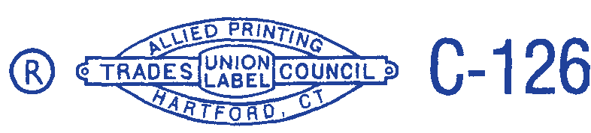



JASON DOKLA

Secretary-Treasurer