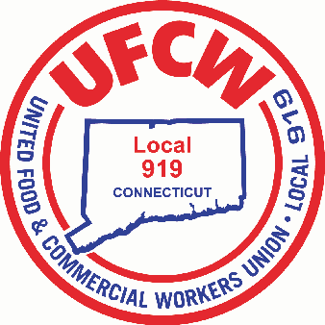

MARK A. ESPINOSA
President

UFCW Local 919
2019 Membership Christmas Toy Drive
Request Form
Today’s Date__________
Your Name (Please Print)________________________________________________________________
Phone Number_______________________________Store #___________________________________
Address____________________________________________________________________________________________________________________________________________________________________

Please provide age and gender of each child (0-12 years of age only)

CHILD AGE CHILD GENDER
_____________________________________________________________________________________________________________________________________________________________________________________________________________________________________________________________________________________________________________________________________________________________________
All Forms MUST be returned to the Union Office by December 14th in order to be selected for a gift

If you have any questions contact the Union Office or your Business Agent at 860-677-9333.

U N I T E D F O O D A N D C O M M E R C I A L W O R K E R S U N I O N

L O C A L 9 1 9

U.F.C.W.
6 Hyde Road • Farmington, Connecticut 06032-2802 • Tel. 860-677-9333 Outside Local Dialing Area 1-800-842-2215
www.ufcw919.org

JASON DOKLA
Secretary-Treasurer

