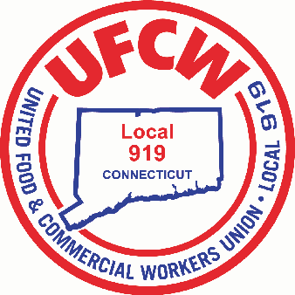

MARK A. ESPINOSA
President
UFCW Local 919
2019
Membership
Christmas Toy Drive!
Please Bring your Un-Wrapped toys to our 7:00 P.M. December 16th General Membership Meeting. All toys collected, will be donated to children of Local 919 Members in need.
Meeting Location: Double Tree By Hilton 42 Century Drive, Bristol CT.
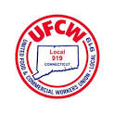
U N I T E D F O O D A N D C O M M E R C I A L W O R K E R S U N I O N

L O C A L 9 1 9

U.F.C.W.
6 Hyde Road • Farmington, Connecticut 06032-2802 • Tel. 860-677-9333 Outside Local Dialing Area 1-800-842-2215
www.ufcw919.org

JASON DOKLA
Secretary-Treasurer

