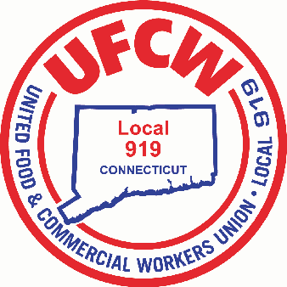

MARK A. ESPINOSA

President

UNION NOTICE

To All UFCW Local 919 Members of Stop & Shop:

We hereby recommend your **ACCEPTANCE** vote at this meeting, of your Employers’ Final Proposal:

**DATE: Thursday, April 25, 2019**

**PLACE: Omni New Haven Hotel at Yale**

**155 Temple St.**

**New Haven, CT 06510**

**TIME: 7:00 P.M.**

**For the opportunity of serving you, we thank you and remain,**

**Sincerely and Fraternally,**

**Mark A. Espinosa James R. Wallace Jr.**

**President Secretary-Treasurer**

**BE PROMPT – BE INFORMED**

**MAKE YOUR VOICE HEARD**

U N I T E D F O O D A N D C O M M E R C I A L W O R K E R S U N I O N

**L O C A L 9 1 9**

U.F.C.W.

6 Hyde Road • Farmington, Connecticut 06032-2802 • Tel. 860-677-9333 Outside Local Dialing Area 1-800-842-2215

[www.ufcw919.org](http://www.ufcw919.org/)

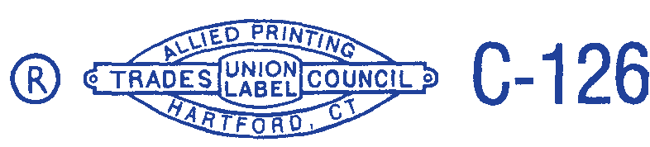



JAMES R. WALLACE, JR.

Secretary-Treasurer