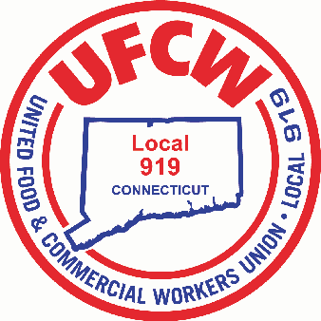

MARK A. ESPINOSA

President



U N I T E D F O O D A N D C O M M E R C I A L W O R K E R S U N I O N

**L O C A L 9 1 9**

U.F.C.W.

6 Hyde Road • Farmington, Connecticut 06032-2802 • Tel. 860-677-9333 Outside Local Dialing Area 1-800-842-2215

[www.ufcw919.org](http://www.ufcw919.org/)





JAMES R. WALLACE, JR.

Secretary-Treasurer