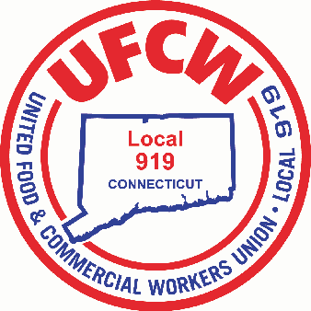

MARK A. ESPINOSA

President

May 16, 2018

TO ALL UFCW LOCAL 919 MEMBERS

Dear Sisters and Brothers:

**Re: Per Capita Increase**

At the recent 2018 Eighth Regular Convention of the UFCW International Union, the delegates voted to amend Article 18 (A)3 of the International Constitution, which sets forth per capita to the International Union. Our delegates considered the need for a strong and effective Union that has the resources to organize and grow, to bargain better wages and working conditions for our members and to fight for the dignity and equality for all workers.

The financial health of the International Union is critical in fulfilling our core mission of organizing and negotiating better contracts for our members. Accordingly, the delegates at the Convention adopted a per capita increase, which becomes effective July 1, 2018, and will be reflected on the invoices being sent to local unions on or about July 10, 2018.

In conjunction with this per capita increase, Article 38(A)3 of the International Constitution provides for a simultaneous automatic increase in local union dues of **$0.46 cents per week** per member. No further Local Union membership approval is required to implement this dues increase.

Although this Local Union is never thrilled to pass on **ANY** increases to our membership, it should be noted that this is the first increase since October 1, 2013. As stated above; the financial health of the International Union is critical. In addition, your Local Union’s financial health is vital particularly as we approach another bargaining period with your Employer, Stop & Shop.

For the honor and privilege of serving you, I am

Sincerely and fraternally,

Mark A. Espinosa

President

U N I T E D F O O D A N D C O M M E R C I A L W O R K E R S U N I O N

**L O C A L 9 1 9**

U.F.C.W.

6 Hyde Road • Farmington, Connecticut 06032-2802 • Tel. 860-677-9333 Outside Local Dialing Area 1-800-842-2215

[www.ufcw919.org](http://www.ufcw919.org/)





JAMES R. WALLACE, JR.

Secretary-Treasurer