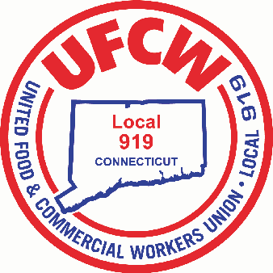

MARK A. ESPINOSA

President

Dear Sisters and Brothers, 6/28/18

As your President, of this Great Local Union, I am saddened and disappointed with the Supreme Court’s decision regarding Janus. Make no mistake, this is not just attack on Public-Sector workers, but an attack on Collective Bargaining rights of ALL workers! You may think that this decision does not affect you as a private sector Union Member, it will. This monumental decision brings us closer than ever to National “Right-to-Work” legislation. Employers are keeping a close eye on this. Currently there are 27 states in the country that have this legislation. Connecticut is only one of 23 states left that does not have the law in place. We believe that if a Republican Governor is elected this year, and the State Assembly becomes Republican-controlled, “Right-to-Work” legislation will indeed become law. Public Sector Union workers are still able to enjoy the benefits of a contract along with representation **without** having to pay Union dues or agency fees. This law is entirely unjust and unfair as it leaves Union Members carrying the full share of financial support while many will just benefit freely. Imagine if you will, that you refuse to pay your car insurance but are still allowed to maintain an insured vehicle and the protection of it. Does this make sense?

UFCW International Union President Marc Perrone issued this release today;

**“This decision will lead to increased income inequality and needlessly make it more difficult for every hard-working union family to build a better life.** **Unions like ours offer a true path for people to earn higher pay and high-quality benefits that are affordable.** **While the Supreme Court has chosen to ignore the value unions offer and the good we do, we will never stop proving the incredible good that comes to hard-working men and women when they unite together.”**

Lori Pelletier, President of the CT AFL-CIO, in statement today stated;

**“The billionaires and corporate CEOs who supported the *Janus* case are attempting to divide working people and limit our power in numbers,” Pelletier continued. “They know that unions give workers a powerful voice in speaking up for themselves, their families, and their communities.”**

Please know the real intent of this Supreme Court decision is derived from a “right-wing” conservative, anti-union agenda. While the rhetoric will spin and try to convince the public that it is merely trying to give workers the freedom of choice, the ultimate outcome will be the total annihilation of the Labor Movement through a gradual financial insolvency. If there was ever a time to fully support the hard-earned gains the Union Movement has achieved, it is now! We must support each other so that we maintain the ability to provide strong and effective operating power. We cannot be viewed by any employer as a “paper tiger”. If any of you have ideas on how better we can protect OUR future, please do not hesitate to contact Your Union so that we may be able to mobilize an even more united front.

For the honor and privilege of serving you, I am

Sincerely and fraternally,

Mark A. Espinosa

President

U N I T E D F O O D A N D C O M M E R C I A L W O R K E R S U N I O N

**L O C A L 9 1 9**

U.F.C.W.

6 Hyde Road • Farmington, Connecticut 06032-2802 • Tel. 860-677-9333 Outside Local Dialing Area 1-800-842-2215

[www.ufcw919.org](http://www.ufcw919.org/)

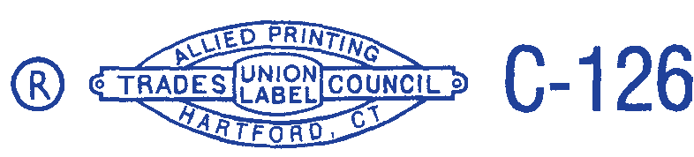



JAMES R. WALLACE, JR.

Secretary-Treasurer