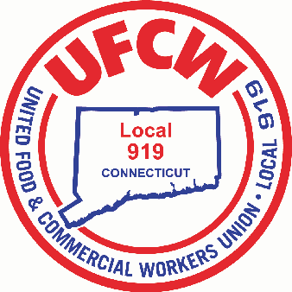

MARK A. ESPINOSA
President

What is the Value of Your Union Membership?

For less than a $1.40 a day, our Union Members earn thousands of dollars in higher wages, pensions, and other great benefits. Most importantly, you receive a real Contract that guarantees what you earn. We not only negotiate the contracts that improve your lives, our Members get the opportunity to approve each contract. We also put even more money in your pockets when you take advantage of exclusive member discounts. Compared to everything you could spend money on, there is no greater value than being a member of the UFCW, because the simple truth is – the value of a Union Contract far exceeds the cost of membership.

U N I T E D F O O D A N D C O M M E R C I A L W O R K E R S U N I O N

L O C A L 9 1 9

U.F.C.W.
6 Hyde Road • Farmington, Connecticut 06032-2802 • Tel. 860-677-9333 Outside Local Dialing Area 1-800-842-2215
www.ufcw919.org
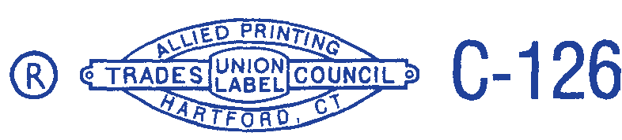

JAMES R. WALLACE, JR.
Secretary-Treasurer

