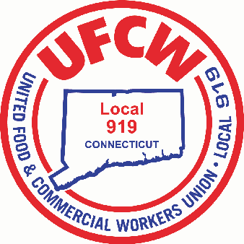

MARK A. ESPINOSA

President

10/24/2016

Dear Membership,

We wish to notify you that the pilot program of the Negotiated Two-Week Schedule Program will begin the week of October 23rd 2016. The Union Contract states; **Article 28 - Work Schedules**, “The Company will implement a two-week advanced scheduling program by the end of 2016. The Company will meet with the Union prior to the advance scheduling program and after the program to discuss and negotiate the broader implementation…..The Company and the Union will discuss any testing issues of the advanced scheduling program and make modifications as needed. The parties will agree to a date for a full rollout of the two (2) week advanced scheduling program, beginning no later than June 1, 2017.”

The two selected pilot stores are #478 (Braintree, MA) and #650 (Fairfield, CT). The Company states the schedule posted the week of October 23rd will cover the two-week period from Sunday, October 30th through Saturday, November 12th. Thereafter, a one-week schedule will be written and posted for two weeks out.

We will keep you informed of this rollout. We fought hard at the bargaining table for this important language, as we believe it serves to provide you with valuable flexibility and planning in your busy lives.

For The Honor of Being Your Voice On the Job,

UFCW Local 919

U N I T E D F O O D A N D C O M M E R C I A L W O R K E R S U N I O N

**L O C A L 9 1 9**

U.F.C.W.

6 Hyde Road • Farmington, Connecticut 06032-2802 • Tel. 860-677-9333 Outside Local Dialing Area 1-800-842-2215

[www.ufcw919.org](http://www.ufcw919.org/)

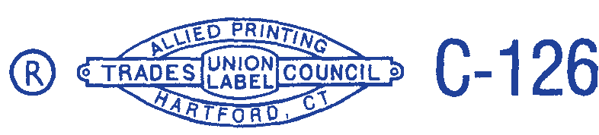



JAMES R. WALLACE, JR.

Secretary-Treasurer