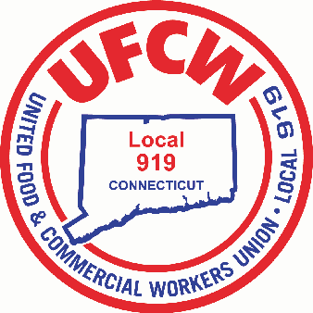

MARK A. ESPINOSA

President

**Dear Bob’s Discount Furniture Member,**

Below is an excerpt from the latest communication between this Union and your Employer;

 A few highlights about what we’re doing for our employees during this crisis:

·       Recognizing that this week was a difficult week where some stores closed before the week was over, we are paying employees who worked in a store that closed before Sunday the greater of their average weekly hours worked in 2020 or their actual hours worked for the week. Although commission employees will be paid their draw rate, when their commission settlement for this week is made, if their resulting earnings are less than their vacation rate per hour, we will pay the difference to them.

·       We’re freezing commission deficits as of 3/15. Commission deficits will not be added to or clawed back until the furlough is over.

·       We’re placing employees on furlough leave of absence effective Monday 3/23, retaining their employment at Bob’s, their position, original hire date, and benefits. We have every intention of returning employees to their roles when business conditions return to normal.

·       The first week of furlough will be paid using the employee’s 2020 average weekly hours. Commission employees will be paid their vacation rate.

·       After the first paid week; furlough will continue unpaid.

·       While on furlough, trailing commissions earned will be paid to associates with no settlement against draw paid.

·       Bob’s insurance will continue at least until the end of April, and Bob’s will cover any employee contributions while the employee is on unpaid furlough.

·       We’re providing our employees information about how to contact our various benefit partners as well as how to file for unemployment.

Local 919 is fully committed to assisting you in any way that we can during the very difficult time. Local 919 will also continue to communicate with your Employer during this furlough. Please do not hesitate to contact us with ANY questions. We wish health and safety for you and your families as we deal with this entire situation. Please do not wait to file for unemployment @ http://www.ctdol.state.ct.us/UI-online/index.htm.

Fraternally,

United Food & Commercial Workers Union, Local 919

U N I T E D F O O D A N D C O M M E R C I A L W O R K E R S U N I O N

**L O C A L 9 1 9**

U.F.C.W.

6 Hyde Road • Farmington, Connecticut 06032-2802 • Tel. 860-677-9333 Outside Local Dialing Area 1-800-842-2215

[www.ufcw919.org](http://www.ufcw919.org/)

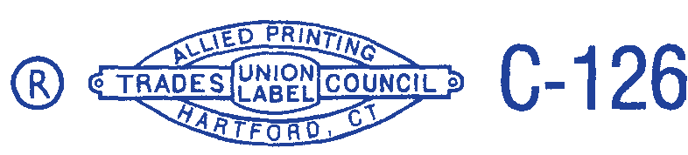



JASON DOKLA

Secretary-Treasurer