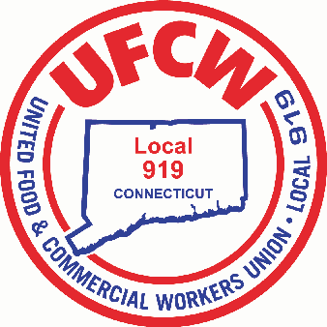

MARK A. ESPINOSA
President

November 28, 2016

ATTENTION ALL VERNON CAFETERIA EMPLOYEES,
MEMBERS OF UFCW LOCAL 919:

This is to notify you that a meeting has been scheduled for:

DATE: Wednesday, December 7, 2016

TIME: 3 p.m.

PLACE: Vernon Police Department
725 Hartford Tpke
Vernon, Connecticut

AGENDA: General discussion

Sincerely and fraternally,

Mark A. Espinosa James R. Wallace, Jr.
President Secretary-Treasurer

Joanna Santana
Business Agent

U N I T E D F O O D A N D C O M M E R C I A L W O R K E R S U N I O N

L O C A L 9 1 9

U.F.C.W.
6 Hyde Road • Farmington, Connecticut 06032-2802 • Tel. 860-677-9333 Outside Local Dialing Area 1-800-842-2215
www.ufcw919.org
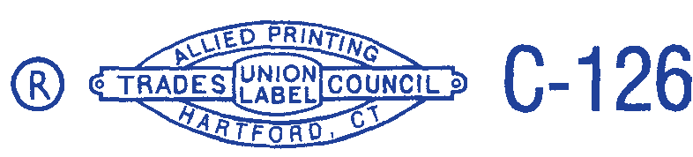

JAMES R. WALLACE, JR.
Secretary-Treasurer

