******* STOP & SHOP NEGOTIATION UPDATE *******

March 28, 2019
Sisters and Brothers:

We wanted all of you to know immediately that Stop & Shop just gave us a so-called “final offer” that ignores all of your hard work and is completely unacceptable. While we understand your frustrations with Stop & Shop, we want you to also know that a “final offer” doesn’t necessarily mean “last offer,” so there may still be room to negotiate. We have called in a federal mediator to give Stop & Shop one last chance to do the right thing.

Among the significant cuts that Stop & Shop has proposed include the following: (1) replacing real wage raises with so-called bonuses, (2) significantly cutting to your health and welfare benefits, and (3) significantly increasing your weekly healthcare contributions.

Make no mistake, Stop & Shop’s proposal is a wage and benefit cut and will have an adverse effect on the overwhelming majority of New England’s 31,000 hardworking Stop & Shop workers.

Given your hard work, the level of customer service you provide, and the personal sacrifices you make every day to make this company a success, this proposal is an insult.

To be clear, this union family will stand together and is determined to win the better wages and benefits that all of you have earned and deserve.

As part of this commitment, we are mobilizing our communities - and our customers and their families - to send a powerful message that such cuts are not acceptable.

Our message to Stop & Shop is a simple one: we will not sacrifice the lives of our members and it is time they move off of these unreasonable and harmful cuts.

No matter what, we want all of our members to know that we are mobilizing all of our union family, and all of our supporters and customers across the entire region.

It is our goal that the executives of Stop & Shop, a multi-billion-dollar, international conglomerate, wake up and realize that what they have proposed is wrong. And, that we will fight for each other to ensure that Stop & Shop jobs remain good jobs across New England.

In the meantime, stay strong, wear your buttons and pack warm clothes and comfortable shoes. Most importantly, let the company know that these cuts are unacceptable.

Sincerely,

Your UFCW Stop & Shop Negotiation Coalition
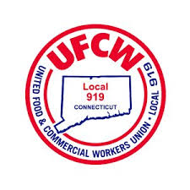
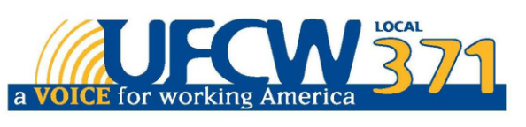
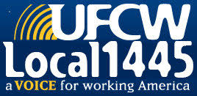

UFCW Local 328 Pres. Tim Melia, UFCW Local 371 Pres. Tom Wilkinson, 1445 Pres. Jeff Bollen, UFCW Local 1459 Pres. Tyrone Housey, UFCW Local 919 Pres. Mark Espinosa

