**UPDATE TO ALL UFCW STOP & SHOP MEMBERS**

April 9, 2019

Members,

Today, we sent the company a comprehensive contract proposal that:
- protects the pension benefits that our current and future members have earned and deserve;
- fully maintains health and welfare benefits for all current and future members; and
- provides innovative wage rates that address our members’ concerns about government mandated minimum wage increases while allowing the company to remain competitive.

Stop & Shop’s success has been built by hard-working members like you who strive to provide customers with the exceptional service and high-quality shopping experience that they deserve.

Thanks to your hard work, Stop & Shop has become the top supermarket operator in New England and its parent company, Ahold Delhaize, made over $2 billion in profits in 2018.

It’s time for Stop & Shop to acknowledge the full value of the hard-working women and men who have made it so successful. Which is why our proposal is not just reasonable and the right thing to do, it’s the most responsible.

Standing United,
Your UFCW Local Union Leadership

P.S. Don’t forget to text “SSUpdates” to 698329 to receive UFCW Members only updates.
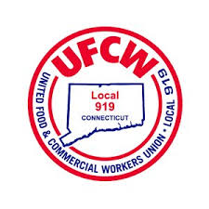

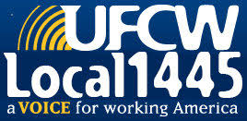
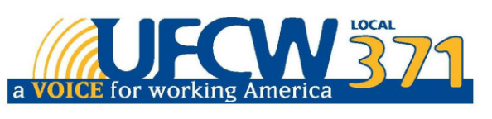

UFCW Local 328 Pres. Tim Melia, UFCW Local 919 Pres. Mark Espinosa, UFCW Local 1459 Pres. Tyrone Housey, UFCW 1445 Pres. Jeff Bollen, UFCW Local 371 Pres. Tom Wilkinson

