****** UPDATE ALL UFCW STOP & SHOP MEMBERS ******
April 17, 2019
Members,
You may have received some information from the company today in an effort to break the unity and strength you have shown over the past several days.
The company has also chosen to take dues out of your paychecks this week in an effort to weaken your resolve.
To be clear, each of your Locals will refund any amount of dues taken from your check this week by the company.
Please know that you have taken a monumental step in standing up for what’s right and it is having a huge impact. In fact, a retail consulting firm told The Boston Globe “In nearly 30 years, we haven’t seen a strike as effective and devastating as this one.”

The community is with you in this fight. Your customers, neighbors, family, and friends all know that this is about protecting good jobs so that we can continue providing the type of service that makes our customers stand with us.

We met several times with the company today and both sides exchanged proposals. However, they still haven’t moved from their wage proposal and other substantial issues that matter to you and your coworkers. We will be back at the table tomorrow to continue to work towards an agreement that will make Stop & Shop better for workers and shoppers.

Standing United,

Your UFCW Local Union Leadership

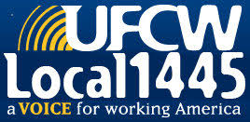
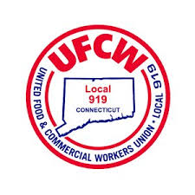
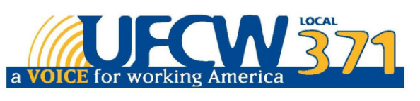

UFCW Local 328 Pres. Tim Melia, UFCW Local 1459 Pres. Tyrone Housey, 1445 Pres. Jeff Bollen, UFCW Local 919 Pres. Mark Espinosa, UFCW Local 371 Pres. Tom Wilkinson

