***** UPDATE ALL UFCW STOP & SHOP MEMBERS *****

April 8, 2019

Members,

Many of you have seen posted notices of Stop & Shop’s “final offer” in your stores and on their website. Make no mistake, nothing is considered “final” on our end. We go back into negotiations tomorrow and we will not agree to any proposals that will hurt you and your families, or your reputation for providing quality service.

If management tries to give you any information about a new contract or new policies, contact your union rep immediately.

Remember, when the company tries to give you their corporate spin, you don’t have to listen. If you have questions, talk to your rep. Help your coworkers stay informed. Tell them to sign up for the latest members ONLY updates.

Text “SSUpdates” to 698329 to receive UFCW Members ONLY updates.

The truth is, Stop & Shop continues to push for broad cuts to health care, take-home pay, and retirement benefits that are simply unreasonable. A multibillion-dollar corporation that is as successful and profitable as Stop & Shop in New England should and can provide strong benefits for its workers. You are the people whose hard work has made Stop and Shop successful. They can and must do better for you.

We want to thank those of you who have taken the time to reach out to us to let us know how you are doing during the negotiation process. Your feedback and participation is important in making our union stronger. Some of you have expressed frustration by the current uncertainty while waiting for a new contract. That is very understandable. Make no mistake, you are not alone. 31,000 Stop & Shop workers in New England are standing with you. We all deeply appreciate everything that you are doing to stand with them during this time.

You work hard. You made Stop & Shop New England’s top grocery chain. Together, we will fight to get the contract that values your work because you earned it.

In solidarity,

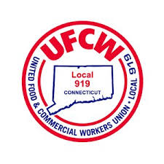
Your UFCW Local Union Leadership
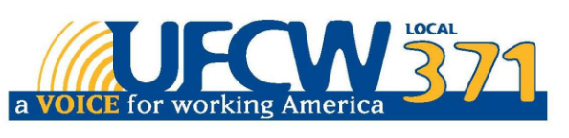
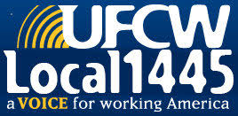

UFCW Local 328 Pres. Tim Melia, UFCW Local 371 Pres. Tom Wilkinson, 1445 Pres. Jeff Bollen, UFCW Local 1459 Pres. Tyrone Housey, UFCW Local 919 Pres. Mark Espinosa

