**** UPDATE FOR ALL UFCW STOP & SHOP MEMBERS ****

April 19, 2019

Members,

We met with the company again today and reinforced our commitment to a contract that reflects the value of our hard-working members.

There are still significant items on the table that the company would like to take away.

We have been getting reports that workers are getting scheduling notices for next week from the company. The company has told us this is just a computer error. There is no deal yet. We will continue keeping you updated on our progress.

We are continuing to work hard to get a deal as soon as possible and will be meeting with the company late into the evening. In the meantime, stay strong and stay united on the line. Know that your community is standing with you.

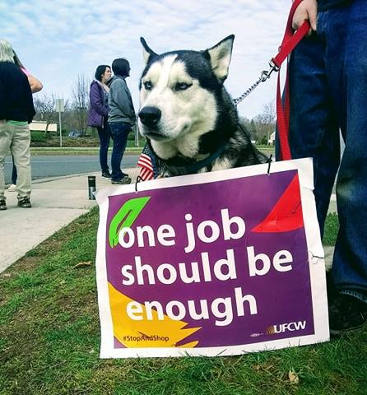

Standing United,

Your UFCW Local Union Leadership
P.S. – If you haven’t already, follow Support Stop & Shop Workers on Facebook and Twitter.
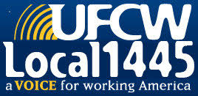
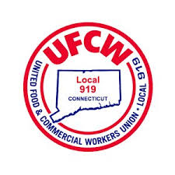
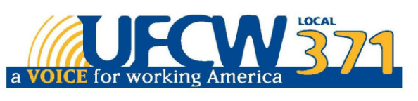

UFCW Local 328 Pres. Tim Melia, UFCW Local 371 Pres. Tom Wilkinson, 1445 Pres. Jeff Bollen, UFCW Local 1459 Pres. Tyrone Housey, UFCW Local 919 Pres. Mark Espinosa

