***** UPDATE ALL UFCW STOP & SHOP MEMBERS *****

April 7, 2019

Members,

On Monday, Local leadership will be speaking to the members in the stores. While we continue to be available to bargain via phone and email today and tomorrow, at the request of the mediators we will meet with the company again, in person on Tuesday.
Please continue to speak to your Stewards and Union Reps for the latest information and as always, please immediately report any bad behavior by management.

In solidarity,

Your UFCW Local Union Leadership

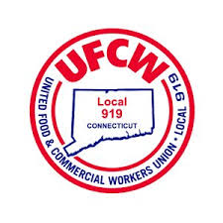
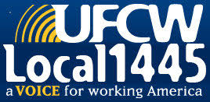
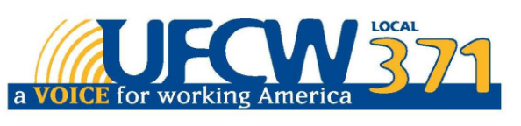

UFCW Local 328 Pres. Tim Melia, UFCW Local 371 Pres. Tom Wilkinson, 1445 Pres. Jeff Bollen, UFCW Local 1459 Pres. Tyrone Housey, UFCW Local 919 Pres. Mark Espinosa

