******* STOP & SHOP NEGOTIATION UPDATE *******

April 4, 2019

Members:

No progress was made today as the company is continuing to propose senseless and mean-spirited demands of the membership that will hurt both members and the customer.

Just like yesterday, the federal mediator has requested that all five Locals meet again tomorrow morning.

We will continue to keep you updated.

In solidarity,

Your UFCW Stop & Shop Negotiation Coalition
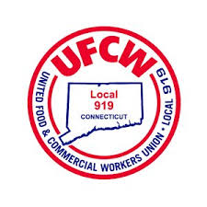
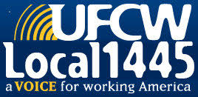
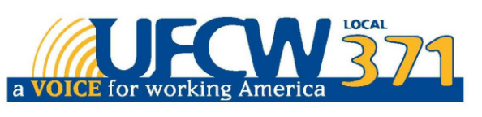

UFCW Local 328 Pres. Tim Melia, UFCW Local 919 Pres. Mark Espinosa, UFCW Local 1459 Pres. Tyrone Housey, UFCW 1445 Pres. Jeff Bollen,
UFCW Local 371 Pres. Tom Wilkinson

