******* STOP & SHOP NEGOTIATION UPDATE *******

April 3, 2019

Brothers and sisters:

The company is continuing to be unreasonable, so no progress was made today.

The federal mediator has requested that all five Locals meet again tomorrow morning.

We will keep you updated.

In solidarity,

Your UFCW Stop & Shop Negotiation Coalition
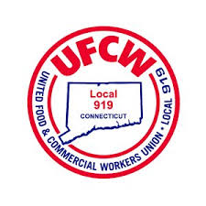
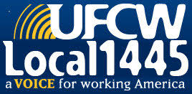
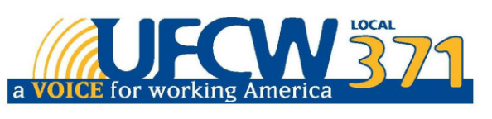

UFCW Local 328 Pres. Tim Melia, UFCW Local 919 Pres. Mark Espinosa, UFCW Local 1459 Pres. Tyrone Housey, UFCW 1445 Pres. Jeff Bollen,
UFCW Local 371 Pres. Tom Wilkinson

