********* UPDATE ALL UFCW STOP & SHOP MEMBERS *********
April 13, 2019

Members,

Today we instructed the federal mediators to contact the company in an effort to continue negotiations, which just ended about five minutes ago. Although there was discussion, we made little progress.

And tomorrow is one of the most important days for this fight.

Going into Sunday, the busiest shopping day of the week, it is imperative that we hold and build the line and keep talking to customers about what this protest is about: maintaining benefits, protecting health care, and keeping good jobs for New England families.

We will continue to update you with breaking information. Text “SSUpdates” to 698329 to receive breaking news and alerts from the negotiation table, and tomorrow, we’ll have an update on strike funds and unemployment benefits. So, stay tuned and keep informing customers that we’re doing this for better jobs, better customer service, and better lives for us all.

Some reminders:

• Make sure your friends, neighbors have all signed and shared the customer petition telling Stop & Shop to do the right thing.

• Continue positively engaging customers. You should have handbills and sign up forms. Tell customers that they can text “Support” to 698329. Let your friends and neighbors know why you are protesting Stop & Shop and how important it is to not cross the picket line.

• And when you’re on the line, stay visible in front of entrance doors, stay active and moving so customers know what’s happening and to not shop, especially tomorrow.

The most important thing we can do right now is to remind the company of our strength and ability to mobilize customers on the busiest shopping day of the week-- tomorrow. Remember, nothing can replace your relationships with customers, no one can tear down the service and success that you’ve built.

Standing United,

Your UFCW Local Union Leadership
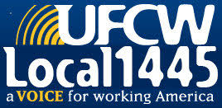
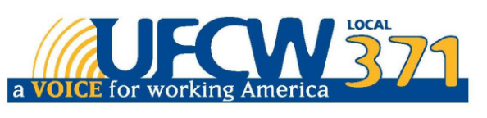
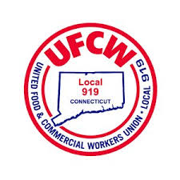

UFCW Local 328 Pres. Tim Melia, UFCW Local 371 Pres. Tom Wilkinson, 1445 Pres. Jeff Bollen, UFCW Local 1459 Pres. Tyrone Housey, UFCW Local 919 Pres. Mark Espinosa

