********* STOP & SHOP NEGOTIATION UPDATE *********
February 28, 2019

Brothers and Sisters:

Yesterday, Stop & Shop’s parent company, Ahold Delhaize, released its 2018 financial report (which showed over $2 billion in profit) and the headlines are astounding:

Ahold Delhaize profit beats expectations, Market Watch
Ahold Delhaize closes out fiscal year on an up note, Supermarket News
Giant Food Stores parent company reports solid 2018 results, WFMZ
Ahold Delhaize Posts Healthy Q4, Full-Year Growth, Progressive Grocer
Ahold says on course to meet U.S. online sales growth targets, Reuters
Ahold says on course to meet U.S. online sales growth targets, Yahoo Finance
Ahold Delhaize Refreshes Stop & Shop Banner, Reports Quarterly Results, Deli Market News
Giant Food Stores parent company reports solid 2018 results, WFMZ
Ahold Delhaize reports increased sales in U.S. for fourth quarter, Storebrands
"Strong quarter" for Ahold Delhaize, Fruitnet

So astounding, in fact, that Ahold’s CEO and President, Frans Muller, had this to say:

“Today, Ahold Delhaize is fit for the future, with a very robust financial profile and the right structure to further grow our brands, both in-store and online.”

So, why is a company that is “solid,” “healthy,” and “strong,” and according to its own CEO, is “fit for the future” today, sitting across from us at the negotiation table trying to cut tens of millions of dollars from the very workers who built their success? Yes, they are still proposing tens of millions of dollars in cuts to your take home pay and benefits. And because of this, minimal progress has been made.

The company is nowhere close to agreeing to a contract that demonstrates the hardworking women and men who have built Stop & Shop’s success, but we remain committed to protecting the wages and benefits you have earned and deserve.

We hope that Stop & Shop doesn’t force us into a fight, but we will be prepared if they do.

In solidarity,

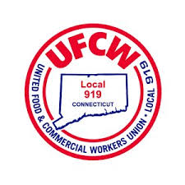
Your UFCW Stop & Shop Negotiation Coalition
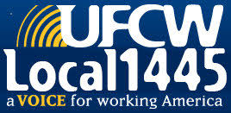
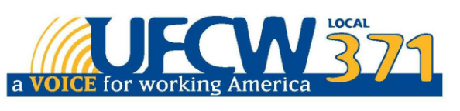

UFCW Local 328 Pres. Tim Melia, UFCW Local 371 Pres. Tom Wilkinson, 1445 Pres. Jeff Bollen, UFCW Local 1459 Pres. Tyrone Housey, UFCW 1445 Pres. Jeff Bollen, UFCW Local 919 Pres. Mark Espinosa

